**Assignment 8 :-**

**1.implement following using GUI**

import javax.swing.*;

import java.awt.*;

import java.awt.event.*;

public class CounterApp {

public static void main(String[] args) {

JFrame frame = new JFrame("Counter");

frame.setSize(400, 100);

frame.setDefaultCloseOperation(JFrame.EXIT_ON_CLOSE);

JPanel panel = new JPanel(new GridLayout(1, 5, 5, 5));

JLabel label = new JLabel("Counter", SwingConstants.CENTER);

final JTextField counterField = new JTextField("0");

counterField.setEditable(false);

final JButton countUpButton = new JButton("Count Up");

final JButton countDownButton = new JButton("Count Down");

final JButton resetButton = new JButton("Reset");

countUpButton.addActionListener(new ActionListener() {

public void actionPerformed(ActionEvent e) {

int count = Integer.parseInt(counterField.getText());

count++;

counterField.setText(String.valueOf(count));

}

});

countDownButton.addActionListener(new ActionListener() {

public void actionPerformed(ActionEvent e) {

int count = Integer.parseInt(counterField.getText());

count--;

counterField.setText(String.valueOf(count));

}

});

resetButton.addActionListener(new ActionListener() {

public void actionPerformed(ActionEvent e) {

counterField.setText("0");

}

});

panel.add(label);

panel.add(counterField);

panel.add(countUpButton);

panel.add(countDownButton);

panel.add(resetButton);

frame.add(panel);

frame.setVisible(true);

}

}

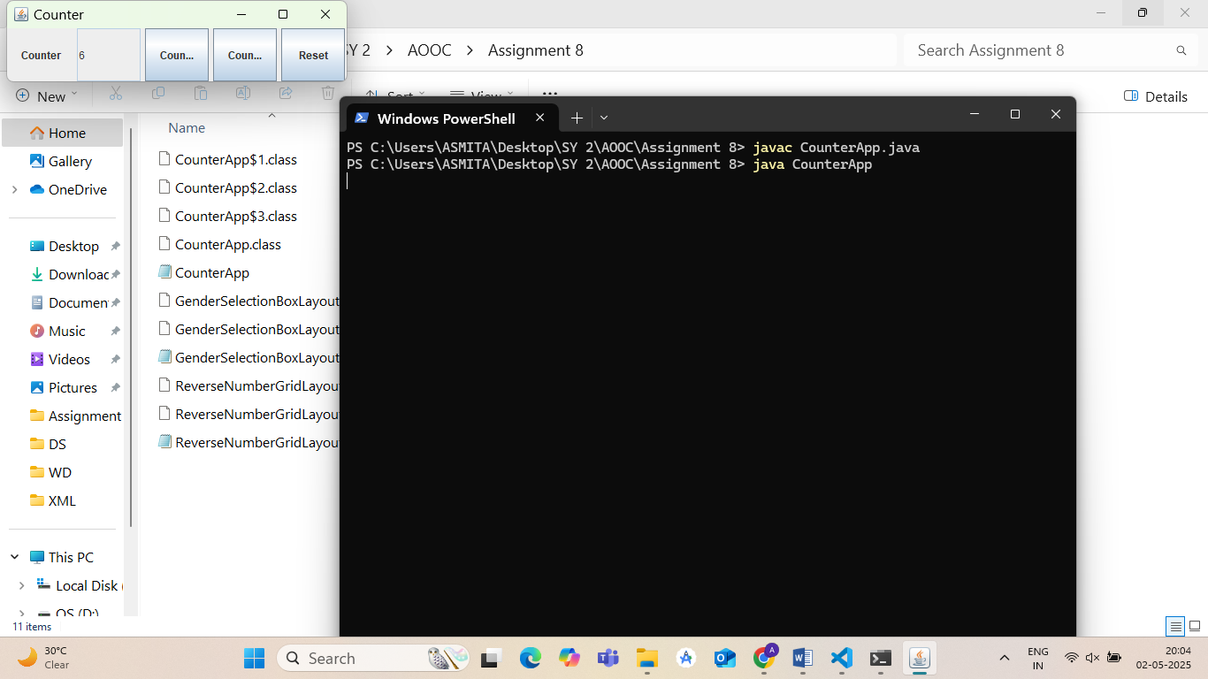

**2. Write a GUI program to find the reverse of a given number using Swing (with IDE).**

import javax.swing.*;

import java.awt.*;

import java.awt.event.*;

public class ReverseNumberGridLayout {

public static void main(String[] args) {

JFrame frame = new JFrame("Reverse Number");

frame.setSize(500, 500);

frame.setDefaultCloseOperation(JFrame.EXIT_ON_CLOSE);

JPanel panel = new JPanel(new GridLayout(4, 1, 10, 10));

final JLabel label = new JLabel("Enter a number:");

final JTextField textField = new JTextField();

final JButton button = new JButton("Reverse");

final JLabel resultLabel = new JLabel("Reversed number will appear here");

panel.setBorder(BorderFactory.createEmptyBorder(20, 20, 20, 20));

button.addActionListener(new ActionListener() {

public void actionPerformed(ActionEvent e) {

try {

int number = Integer.parseInt(textField.getText());

int reversed = 0;

while (number != 0) {

int digit = number % 10;

reversed = reversed * 10 + digit;

number /= 10;

}

resultLabel.setText("Reversed number: " + reversed);

} catch (NumberFormatException ex) {

resultLabel.setText("Please enter a valid integer.");

}

}

});

panel.add(label);

panel.add(textField);

panel.add(button);

panel.add(resultLabel);

frame.add(panel);

frame.setVisible(true);

}

}

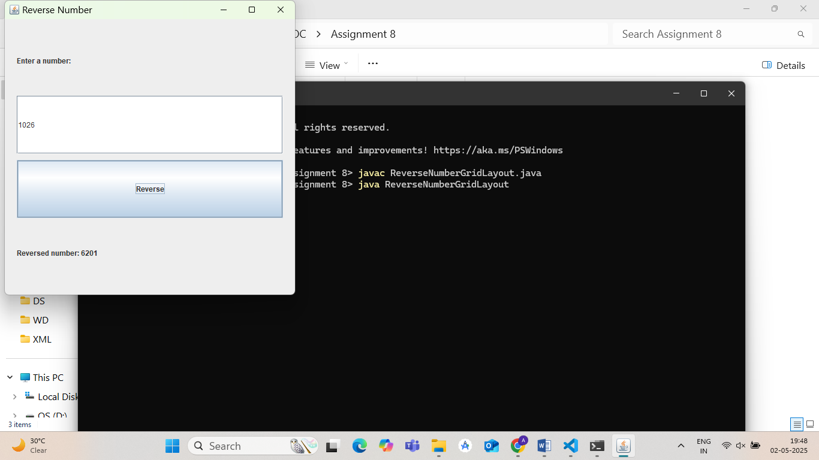

**3. Write a GUI program to demonstrate the use of radio buttons (e.g., gender selection).**

// GenderSelectionBoxLayout.java

import javax.swing.*;

import java.awt.event.*;

public class GenderSelectionBoxLayout {

public static void main(String[] args) {

JFrame frame = new JFrame("Gender Selection");

frame.setSize(400, 400);

frame.setDefaultCloseOperation(JFrame.EXIT_ON_CLOSE);

JPanel panel = new JPanel();

panel.setLayout(new BoxLayout(panel, BoxLayout.Y_AXIS)); // Vertical layout

panel.setBorder(BorderFactory.createEmptyBorder(20, 20, 20, 20));

JLabel label = new JLabel("Select your gender:");

final JRadioButton male = new JRadioButton("Male");

final JRadioButton female = new JRadioButton("Female");

final JRadioButton other = new JRadioButton("Other");

JButton button = new JButton("Submit");

final JLabel resultLabel = new JLabel("Selected gender will appear here");

ButtonGroup group = new ButtonGroup();

group.add(male);

group.add(female);

group.add(other);

label.setAlignmentX(JLabel.LEFT_ALIGNMENT);

male.setAlignmentX(JRadioButton.LEFT_ALIGNMENT);

female.setAlignmentX(JRadioButton.LEFT_ALIGNMENT);

other.setAlignmentX(JRadioButton.LEFT_ALIGNMENT);

button.setAlignmentX(JButton.LEFT_ALIGNMENT);

resultLabel.setAlignmentX(JLabel.LEFT_ALIGNMENT);

button.addActionListener(new ActionListener() {

public void actionPerformed(ActionEvent e) {

if (male.isSelected()) {

resultLabel.setText("Selected Gender: Male");

} else if (female.isSelected()) {

resultLabel.setText("Selected Gender: Female");

} else if (other.isSelected()) {

resultLabel.setText("Selected Gender: Other");

} else {

resultLabel.setText("Please select a gender.");

}

}

});

panel.add(label);

panel.add(Box.createVerticalStrut(10));

panel.add(male);

panel.add(female);

panel.add(other);

panel.add(Box.createVerticalStrut(15));

panel.add(button);

panel.add(Box.createVerticalStrut(15));

panel.add(resultLabel);

frame.add(panel);

frame.setVisible(true);

}

}

